SEMESTER 6th (UG)
Subject: BUSINESS ENVIRONMENT

UNIT IV MONEY MARKET
INTRODUCTION
Money market is a major segment of the organized sector regulated by RBI. It refers to that market, wherein money is borrowed and lent for a short period. Money market deals in short term funds. It is a centre where short term money assets are purchased and sold. It may be defined as the centre for dealing in monetary assets. Money market meets the short term requirements of borrowers and provides liquidity or cash to the lenders.
The money market is a market for short term loans i.e. lees than one year. The term money market does not refer to a particular place or a bazar. The transactions of money market may also be carried out by telephone, mail. letter etc., among people who may never meet one another personally.
Definition of Money Market
Following are the important definition of Money Market:
According to Geoffrey Crowther,
"Money market is a collective name given to the various forms and institutions that deal with the various grades of new money”.
According to J.M. Culbertron,
"Money market is a network of markets that are grouped together because they deal in financial instruments that have a similar function in a economy and are to some degree substitutes front the point of view of holders. The Instruments of the money market are liquid assest : interest bearing debts that mature within a short period of time or callable on demand."
According to S.N. Sen,
"Money Market refers to the organization for the lending and borrowing of short term funds through the use of such instruments as bills of exchange, short term government securities, banker’s acceptance.
According to Reserve Bank of India,
Money Market is the centre for dealing mainly short term character, in monetary assets, it meets the short term requirements of borrowers and provide liquidity or cash to the lenders. It is the Place where short term surplus investible funds at the disposal of financial and other institutions and individuals are bid by borrowers, again compromising institutions and individuals and also the government itself.
The money market is the market which deals in short term credit. So money market may be called as reservoir of short term funds. Short term funds refer to reatively liquid assets i.e. which can be converted into cash without much loss. An asset is termed as short term which has a maturity period of one year or less. Transaction on money market may be for a period of even one day or fifteen days, a month and so on but less than 365 days.

Characteristics of a Developed Money Market
The following are the important characteristics of a developed money market.
Developed Commercial Banking System
Presence of a Central Bank
Characteristics of Money Market

Near Money-Assets
Sub-markets
Availability of Ample Resources
Other factors
Integrated Interest-Rate Structure

1. Developed Commercial Banking System : The banking system should be well-developed and organised for a developed money market. The commercial banks are the most important suppliers of short term funds. So, the various policies of commercial banks such as loan policy, investment policy etc. have a direct impact on the working of money market. Thus, a well co-ordinated and well-integrated commercial bank system is the foremost feature of developed money market.
2. Presence of a Central Bank : A strong central bank is necessary a characteristic of the money market as the heart in the human body. Central bank is called as guardian of the money market. Central bank provides the ultimate liquidity without which a money market cannot function efficiently. Thus, there is always an apex central bank in a developed money market. A powerful central bank controls, regulates and guides the money market.
3. Sub-markets : Another important characteristic of a developed money market is the presence of sub-markets. There are various type of sub-markets each dealing in loans of various maturities. In fact. money market is a group of various sub markets. These sub-markets are markets for call loans, the collateral loans, acceptances, foreign exchange, bills of exchange and commercial and treasury bills.
4. Near Money-Assets : There is a large quantity and variety of financial instruments such as bills of exchange, treasury bills, promissory notes, short dated government bonds, etc. in a developed money market. These number of near money assets are more, the money market is said to be developed. The money market should have the regular supply of these assets. It is the dealers in near money assets who actually infuse life into the money market.
5. Availability of Ample Resources: The availability of ample resources is another important feature of a developed money marke t. A developed money market able to attract financial resources from both within the country and outside the country. Availability of ample funds is essential for the smooth and efficient working of the money market aim at raising their resources.
6. Integrated Interest-Rate Structure: Another important characteristic of a developed money market is that it has an integrated interest-rate structure. The interest rates prevailing in the various sub-markets are integrated to each other. A change in the bank rate leads to proportional changes in the interest rate prevailing in the sub-markets.
7. Other Factors: A developed money market is highly influenced by such factors as restrictions on international transactions, crisis, boom, depression, war, political instability, etc.

STRUCTURE OF THE INDIAN MONEY MARKET
Structurally, Indian money market consists of (i)The financial institutions and the (ii) Constituents or financial instruments of money market. The money market can be broadly divided into two different parts :
(i) Financial Institutions
(ii) Financial Instruments

(I) FINANCIAL INSTITUTIONS
Financial institutions are divided Into organised sector and unorganised sector.
(A) Organised Sector : Organised sector of the Indian money market is that sector whose parts and activities are systematically coordinated by the monetary authority.
The organised sector consists of the following :
1. Reserve Bank of India: Resent Hank of India, being the central hank of the country is at the apex of the Indian money market. Though the Reserve Bank does not enter into direct transactions in the money market, but it p guides and controls the money market through the Bank rate.
2. Commercial Banks: The commercial banks in India are classified into two main groups by the Reserve Bank viz. Scheduled and Non-Scheduled banks. Scheduled banks are those banks which are included in the second schedule to the Reserve Bank of India Act. These banks include State Bank of India and its seven associates, nineteen nationalised commercial banks and the other scheduled banks, foreign banks and the regional rural banks. The non-scheduled banks are other than those included in the second schedule to the RBI Act.
The non-scheduled banks account for only a negligible part of the banking business in the country. The commercial banks dominate the institutions of money market and are considered the backbone of money market. These banks form the largest source of the short term funds for financing trade and commerce in India.

3. P. O. Savings Banks : The post office savings bank system is the oldest in the official small saving scheme in India. The postal saving bank is a government agency created for the purpose of encouragement of thrift and the attraction of savings. Though P.O. saving schemes have received a lot of attention from the investors, but these are not as much popular as the savings deposit accounts with the commercial banks.

4. Non-banking Financial Companies: Non-Banking financial institutions such as the LIC, the GIC and subsidiaries, the UTI also operate in the money market, but only indirectly through banks and not directly.Quasi-Government bodies and large companies also make their short term surplus funds available to the organised market through banks.

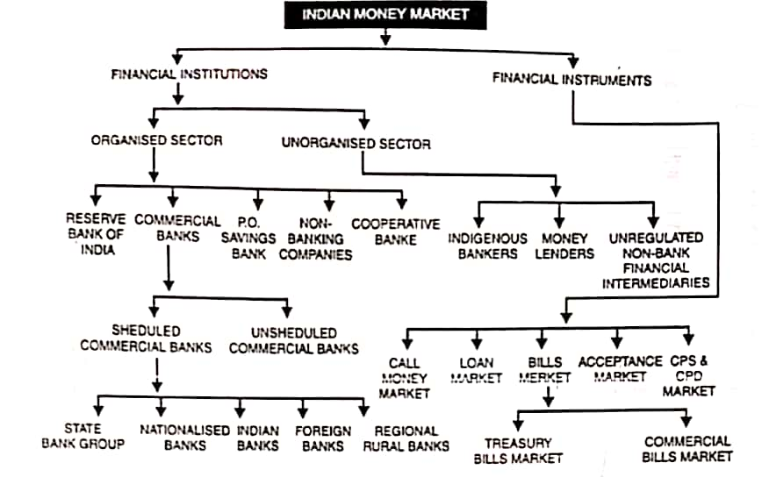
5. Cooperative Banks : Cooperative credit institutions occupy the intermediary position between organised and unorganised parts of the Indian money market. These institutions have a three tier structure. At th• top, there are state cooperative banks. At the district level, there are central cooperative banks. At local level, there are rural primary cooperative banks and urban cooperative banks the state and central banks are included in the organised sector. The cooperative societies at the local level are loosely linked with it.
B. Unorganised Sector
The unorganised sector consists of indigenous banks and money lenders. It is called unorganised because activities or its parts are not systematically coordinated by the Reserve Bank of India.
The following are sonic of the constituents of unorganised money market in India :-
1. Indigenous Bankers: These bankers include those individuals and private firms which are engaged in receiving deposits and giving loans and thereby act like a mini bank. Their activities are not at all regulated. These banks are engaged in both banking and non- banking business, which they do not want to separate. Their lending operations remain mostly unregulated and unsupervised. They charge high rate of interest and they are not influenced by the bank rate policy of the Reserve bank. Nowadays these banks have got somewhat better organised because they enjoy rediscount facilities from the commercial banks, which in turn have links with the RBI. But this type of organisation represents only a loose link with the RBI
2. Unregulated Non-bank Financial : Inter-Mediaries There are different types of unregulated non bank financial intermediaries in India. These are mostly constituted by loan or finance companies, chit funds and nidhis. In India, a good number of finance companies are engaged in collecting substantial amount of funds in the form of deposits, borrowings and other receipts. They normally, give loans to wholesalers, retailers, artisans, and different self employed persons at a high rate of interest ranging between 36 to 48%.There are various types of chit funds in India, doing business in almost all the states.
3. Money Lenders : The money lenders operate through out the country but without any link among themselves. They advance loans to small borrowers like marginal and small farmers, agricultural labourers,artisans, factory and mine workers, low paidstaff, small traders etc at a very high rate of interest and also adopt various malpractices for manipulating loan records of these poor borrowers. There are basically three types of money lenders:—
(i) Professional
(ii) Itinerant money lenders such as Kabul's and pathans,
(iii) Non-professional money lenders.

The money lenders have become a necessary evil in the absence of sufficient institutional credit to the poorer sections of society. Although, various measures have been introduced to control the activities of money lenders, but due to lack of political will these are not enforced, leading to a huge exploitation of small borrowers.

(II) FINANCIAL INSTRUMENTS
The second component of the Indian money market are the financial instruments which provide short term credit. The main constituents of the organised sector of Indian money market include the following :—
1. Call Money Market : The most important form of developed and organised money market is the call money market. This market is the most sensitive segment of the financial system which reflects clearly any change in it. The call money market deals with loans of very short duration. It mainly deals with one day loans which may or may not be renewed the next day. Since, the participants in the call money market are mostly the banks it is also called Inter Bank call money market. Normally, scheduled commercial banks cooperative banks and the Discount and finance house of India (DFHI) operate in this market and in special circumstances the LIC, UPI, the GC, the IDBI and the NABARD are permitted to operate as lenders in this call money market. The banks with temporary deficit of funds form the demand side and banks with temporary excess of funds form the supply side of the call money market.
Banks borrow in this money market for the following purposes :
• To fills the gaps or temporary mismatch in funds.
• To meet the CRR and SLR requirements as stipulated by the central bank.
• To meet sudden demand for funds arising out of large outflows.

In this market, brokers usually play a very important role, as they establish the link between the borrowing and lending banks, The calls loans are generally made without security and therefore the lending bank has to be very careful in Judging the ability of the borrower to repay the loan at call. The rate of interest in these markets is highly unstable. It fluctuates at the pressure of excess demand and excess supply. The call market plays a very important role in removing the day to day fluctuations in the reserve position of the individual banks and improving the banking system in the country. The call money market in India is very much centred at Mumbai, Chennai and Calcutta, Delhi and Ahmedabad and out of which Mumbai is the most important one.

2. Loan Market : Another constituent of money market for short term loans is called collateral loan market. As the name suggests, this market deals with short term collateral loans i.e. loans backed by security. In the Indian collateral loan market, the collateral loans are provided by the commercial banks against the securities, shares and debentures of the government etc. When the loan is repayed the security is returned by the bank, If the borrower fails to repay the loan the collateral security becomes the property of the bank.

3. Bill Market : The bill market deals in various types of short term bills.
The bills are of two types :—
(a) Treasury hills
(b) Commercial bills

The main features of this bill markets are as explained below :—
(a) Treasury Bills Market : Treasury bills markets are markets for treasury bills. Treasury bills are the short term monetary i instruments issued by 'he government of India. In India, these bills are the short term (i.e. 91, 182, and 364 days) liability of the Government of India. These bills are sold by the Reserve Bank of India on behalf of the central government to meet the short term financial requirements of the government. But in reality, these have become a permanent source of funds to the government. These bills are purchased by the Reserve Bank, commercial banks, non-banking financial intermediaries, the LIC, the GIC and the UTI. The Reserve Bank is the highest holder of the treasury bills which is 9Q% of the total. Treasury bills are highly liquid ads the Reserve Bank is always willing to purchase or discount them. The treasury bill market in India is under developed as compared to the treasury bill markets in U.S.A. and U.K.

(b) Commercial Bills : Market Commercial bill market is a kind of submarket, which deals in commercial bills issued by the firms engaged in business. These bills are generally of three months maturity. A commercial bill is a promise to pay a specified sum of money in a specified period by the buyer of the goods to the seller of the goods. The seller who has sold goods on credit, draws the bill and sends it to the buyer for acceptance. After the buyer or his bank writes the word "accepted" on the bill it becomes a marketable instrument and is sent to the seller. The bills are like post dated cheques drawn by the seller of the goods on the buyer of the goods for value received. The bill holder can get the bill discounted in the bill market if he wants the amount of the bill before maturity. In India the commercial bills market is not very developed. There is absence of specialised institutions like acceptance houses and discount houses, particularly dealing in acceptance and discounting business. The Reserve Bank of India has attempted to develop the bill market in our country. However due to some inherent weaknesses, these schemes failed to promote a sound bill market in India.

4.Acceptance Market: The acceptance market deals in banker's acceptances involved in trade transactions. These acceptances are. generally, used in financing the internal trade or import and or export trade. Banker's acceptance is a draft which is drawn by a business firm upon a bank and accepted by the bank whereby the bank is required to pay to the order of a specific party or to the bearer a specific .um of money at a particular future date : The banker's acceptance is different from a cheque. A cheque is payable on demand whereas the acceptance is payable at a specified future date. The banker's acceptance can be sold or discounted in the acceptance market
5. Certificate of Deposit ad Comercial Paper Market : In March 1989, Reserve Bank of India decided to introduce certificate of deposit (CD) and commercial paper (CP) in order to widen the range of money market instruments and give investors greater flexibility in the deployment of their short term surplus funds The CD can be issued only by the scheduled commercial banks in multiple of f 25 lakhs, subject to the minimum size of an issue being Rs 1 crore. Their maturity will vary between three months and one year. The CDs will be freely transferable by endorsement and delivery. Banks will neither be allowed to grant loam against CDs nor can they buy their own CDs.
CPs can be issued by a listed company which has a net worth of at least Rs 25 crores and a working capital limit of not less than Rs 25 acres. CPs can be Issued in multiples of Rs 25 lakhs subject to the minimum size of the issue being Rs 1 crore. Their maturity ranges from 3 months to 6 months. They will be freely transferable by endorsement and delivery Banks will not be permitted to underwrite or to accept the issue of CP.

